The Flood Fill Algorithm

INTRODUCTION
The flood fill algorithm is easily one of the most used algorithms of any maze solving problem. This algorithm gives the shortest possible path from the source to the destination.
Here, we are more specifically talking about the maze solver competition/ micro mouse competitions where an autonomous bot has to solve a maze. The maze is generally divided into a square space called a “cell”. The winner is decided by the bot who solves the maze in the least amount of time.
Many algorithms have been tried out throughout the history, across the world, and for now, the flood fill algorithm comes out as the best among them.

THE ALGORITHM
This algorithm takes place in two phases. The exploration phase, and the execution phase.

The exploration phase:
The main motive of this phase is that the bot has to navigate through all the possible cells on the maze. The bot travels straight, until it finds an intersection, from which multiple paths are possible. On finding such an intersection, the bot arbitrarily takes any one of the multiple paths, and goes on until it finds a “dead end”. On finding a dead end, the bot returns back to the previous intersection. The bot uses a breadth first search (BFS) algorithm to find the path to the previous intersection. Overall, the idea of going deep into one of the paths and then returning back to the previous intersection is of a depth first search (DFS) algorithm.

The execution phase:
Once the exploration phase is completed, the bot has mapped the whole maze, and has a virtual copy of the maze in its memory. Then, each cell is assigned a number called the “cost” of the cell, which is basically the number of cells it is away from the destination cell. For e.g. The destination cell will be 0, its adjacent cells will be 1 and so on.
Then, a path is found such that the sum of the costs of each of its cells is the least possible. This is done by first starting from the starting cell, and then taking the next cell as the cell adjacent to the current cell which has the least cost. i.e. the cell next to it, that is nearest to the destination cell. Automatically, the path produced will be the shortest path possible.

BENCHMARKS:
For testing and benchmarking purposes, we have used the mms simulator which give a 16x16 maze, with the destination cell at (8,8).

Stats after the exploration phase:
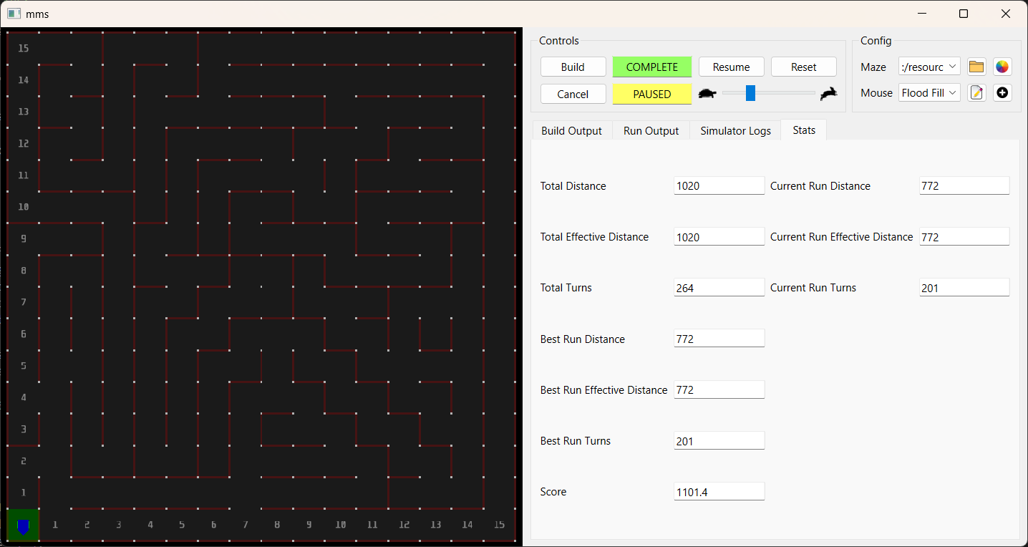

Cost assignment after exploration:
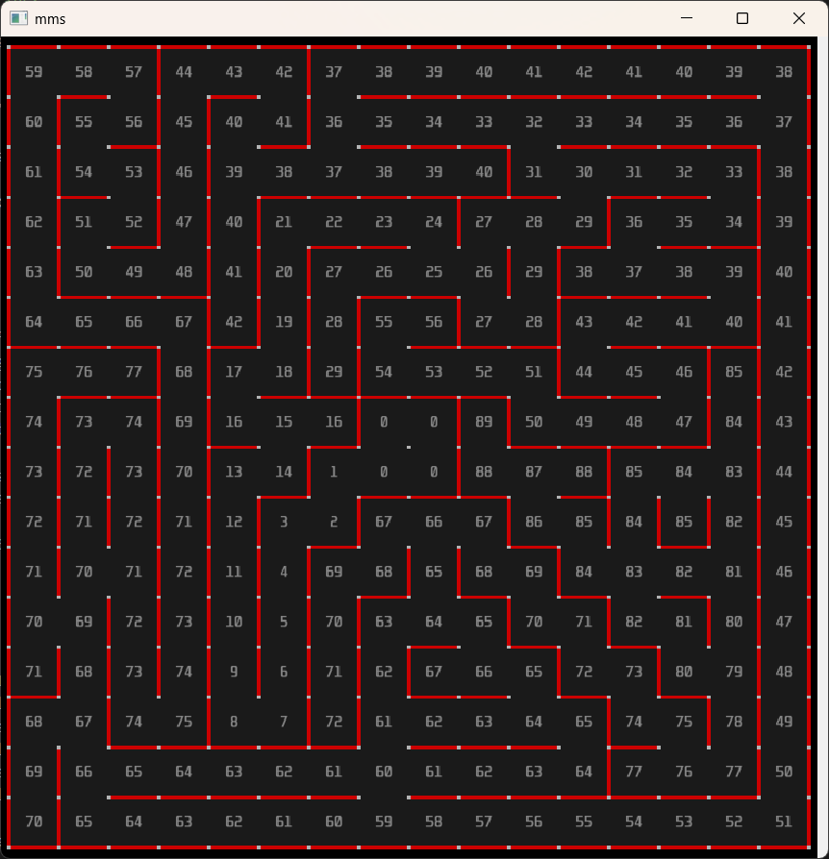

Stats after the execution phase:
